Tasks related to Git and Github-01
open in githbash and install git version
Check the list file (ls) where dockerfile is available or not
Initializing the git

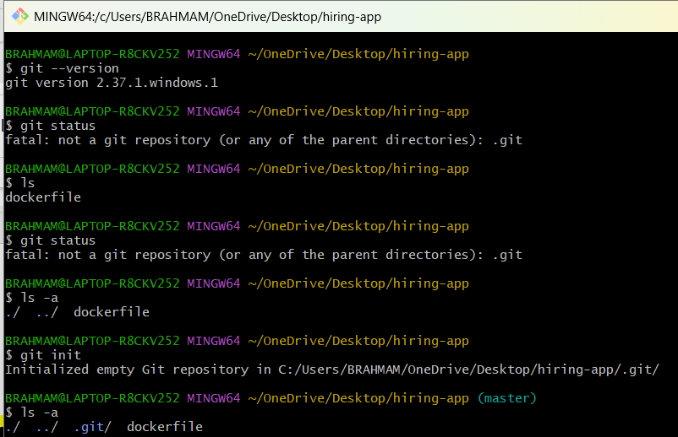
Git status of dockerfile
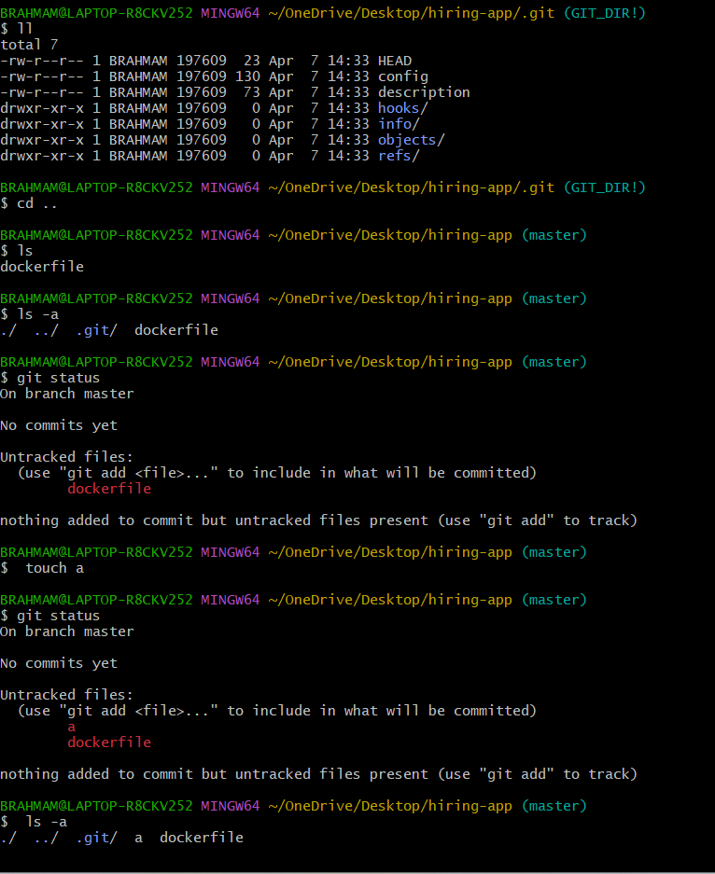
Remove .git/

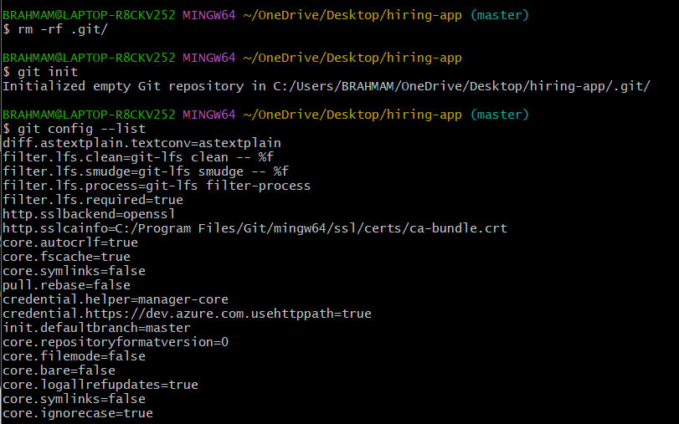
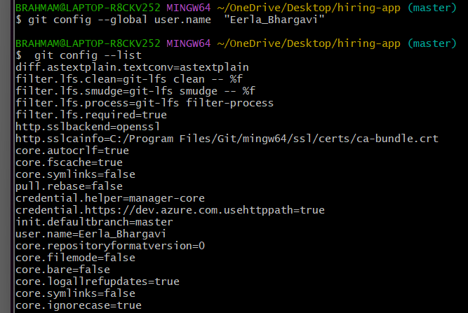
Create our name & mail id :
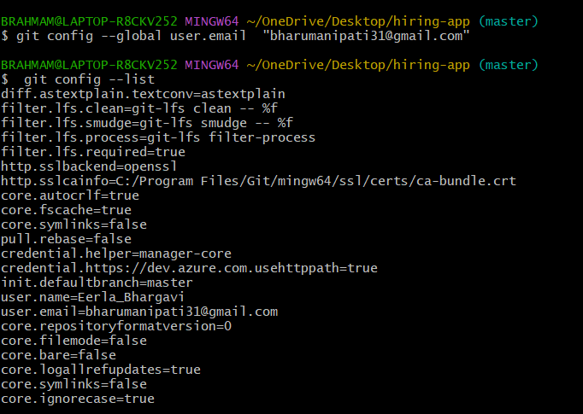
If we want to add a docker file we can givegit add <file>
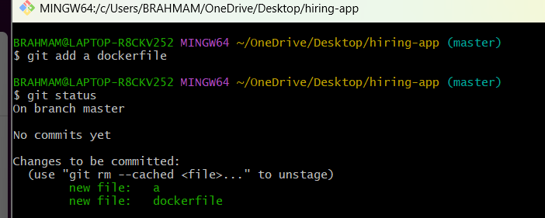
If we want t add give 1000 or 100 files we don’t need to write git add <file> name just we need to give git add .
We see below image
We see status all files will be added successfully…..
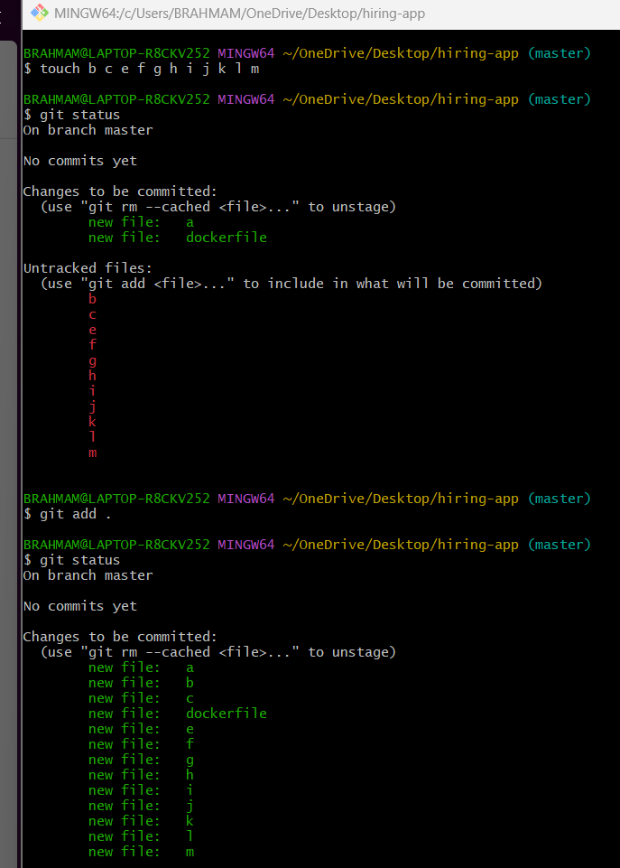
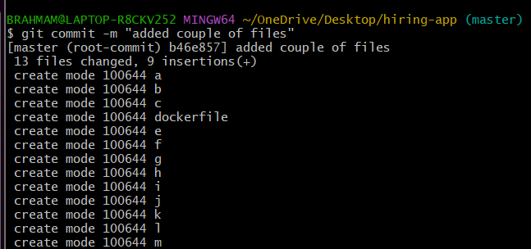
Everything storerd in git log…With the help of commit id first 4 or 5 numbers ….we can see differ commit happens in the repository then we will execute the comments called git log.-->for every commit we can have unique commit ids only..

From the user name and where is that email from the configurations …added couple of files is from commit messages.
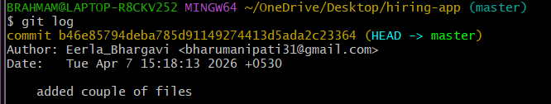
I can add new repository in the github we always use ssh only bec Https have some authentication issues ssh don’t need password or username ok bec we can give password less authentication…
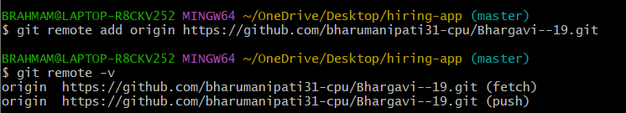
Now our url will be created an one destination.now this account knows where our repository will be stored.
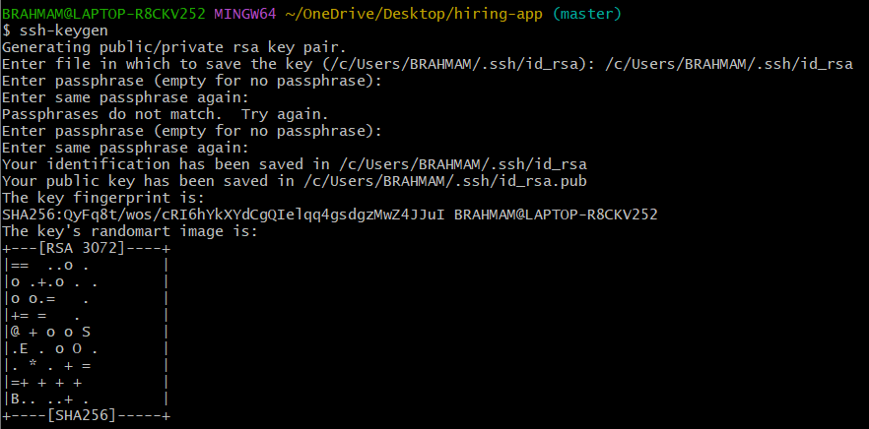
Click on settings select ssh and gpg key click on new ssh keyadd title Add keygen


Created the ssh keygen And added the github SSH link in gitbash for git remote
git push -u origin master
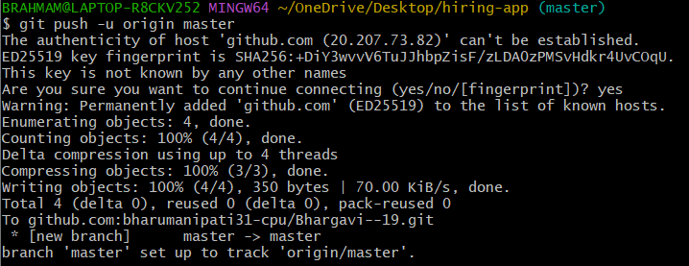
We have to create a one file name as bharu and that will see in git bash then we have to use git pull command seen in below…we have added successfully…
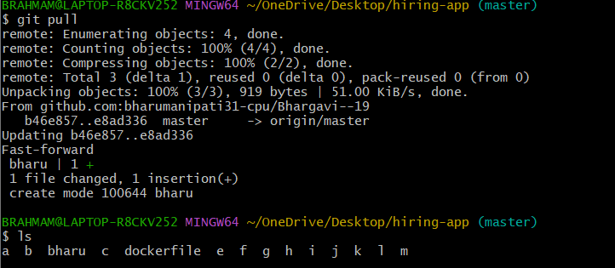
We have created one in git bash ..seen how to push to git hub…
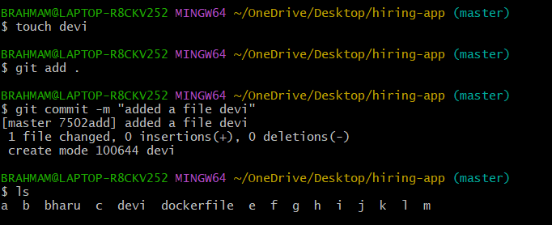
Remove dockerfile
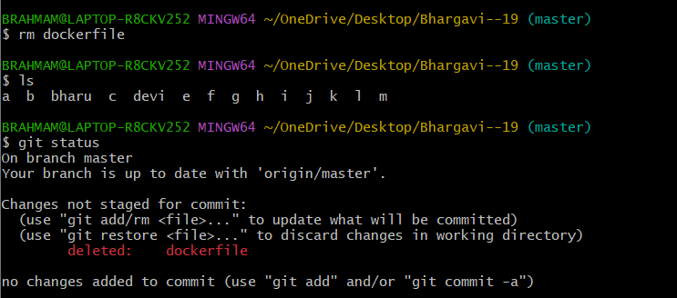
We have to push the devi file in gitbash to github using
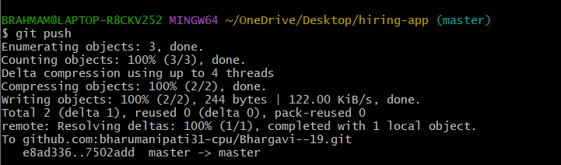
git clone command will use to get the complete details:we get the git hub repository name
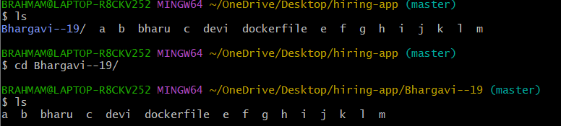
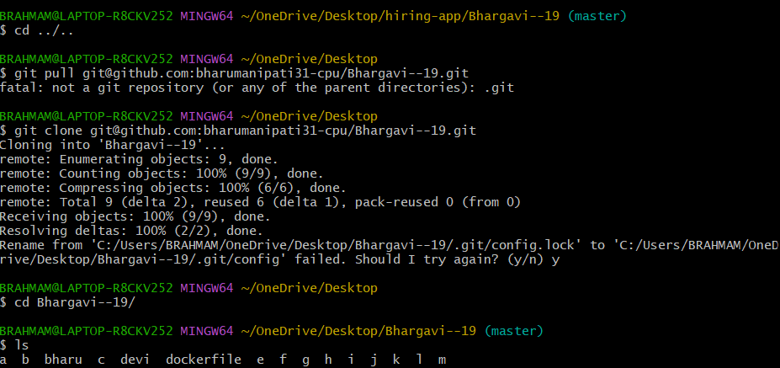
Another commands to pull the changes from central to local
git clone
git fetch
git clone : it will help to get source code from central repository to local machine. Here in the below image the directory is created

